Impacts of Paris Climate Accord Ratification on Renewable Energy Production:

Are Countries Putting Their Money Where Their Mouth Is?

By Matthew Barker

The University of Utah

**I. Introduction/Motivation**

In 2016, every nation on earth officially signed the Paris Climate Accord, which sought to bind the globe in an effort to cut back on greenhouse gas emissions and reverse the frightening trend of global warming. While this was a good first step, there were still nine Middle Eastern nations that, before 2019, had not yet ratified the climate agreement in their home countries: Turkey, Lebanon, Iran, Iraq, Libya, Oman, Eritrea, Yemen, and South Sudan. Ratification is a crucial part of the legislative process, as only signing the agreement is not officially binding. By comparing these countries to other similar countries in the Middle East that have ratified the global agreement, I will be able to explore the environmental impact of ratification versus the impact of simply signing the agreement.

To achieve the lofty goals outlined in the accord, participating governments have identified and begun to implement several different strategies including increasing electric vehicle production and reducing the consumption of carbon-emitting food sources. Despite the popularity of these strategies in some places, they are limited by their scope and accessibility due to certain cultural and economic conditions in different countries. One common strategy across most countries is a push to replace traditional energy sources with renewable energy sources. Countries in the Middle East, where I will be doing my analysis, have traditionally been very reliant on crude oil production to prop up their economies. Due to this high and increasing level of traditional energy production, it will be vital to explore if and how the ratification of the Paris Climate Accord has affected renewable energy production as a percentage of total energy production in the region to better understand if the countries are moving in the right direction to fight climate change.

**II. Data**

To explore this question, I gathered two main data points from Middle Eastern countries before and after the Paris Climate Accord was enacted: renewable energy production and overall energy production. This data was available from the International Energy Agency (IEA), which collects data on energy production by country. Due to the unavailability of more recent data, I was only able to collect energy production numbers from 2014 to 2018. One potential problem with the dataset could be that countries do not accurately report energy production numbers. Many countries might be tempted to cut corners on renewable energy production since it can be expensive and difficult to implement, especially in a region with such a high dependence on crude oil. The IEA is the most-trusted authority on global energy statistics and the organization works closely with national and regional agencies to ensure the accuracy of their data. Because of this quality assurance of IEA and other global pressures to accurately report energy data, this problem is unlikely to cause major issues in the dataset.

**III. Background**

Average country-level total energy production increased in the Middle East between 2014 and 2018. This shows the necessity of using renewable energy production as a percentage of total energy production, as traditional energy production could still be outpacing renewables. Among Middle Eastern countries, five nations produce over 8 million terajoules of energy annually on average: Saudi Arabia, Iran, the United Arab Emirates, Qatar, and Iraq. For context, the United States produced roughly 90 million terajoules of energy in 2018.

|  |  |  |
| --- | --- | --- |
| **Table 1** |  |  |
| **Total Energy Production by Year (measured in terajoules)** | | |
| **Year** | **Mean** | **Std. Dev.** |
| 2014 | 4,414,614 | 6,564,761 |
| 2015 | 4,551,150 | 6,861,494 |
| 2016 | 4,896,768 | 7,335,685 |
| 2017 | 4,905,413 | 7,193,768 |
| 2018 | 5,013,682 | 7,297,053 |

|  |  |  |
| --- | --- | --- |
| **Table 2** |  |  |
| **Total Energy Production by Country (measured in terajoules)** | | |
| **Country** | **Mean** | **Std. Dev.** |
| Bahrain | 951,785 | 8,223 |
| Egypt | 3,254,456 | 297,123 |
| Eritrea | 26,014 | 448 |
| Iran | 15,526,621 | 1,996,977 |
| Iraq | 8,824,329 | 1,451,511 |
| Israel | 295,507 | 33,028 |
| Jordan | 16,240 | 5,196 |
| Kuwait | 6,999,022 | 191,258 |
| Lebanon | 8,617 | 661 |
| Libya | 1,953,541 | 683,853 |
| Oman | 3,276,878 | 112,050 |
| Qatar | 9,392,708 | 73,876 |
| Saudi Arabia | 27,246,045 | 791,502 |
| South Sudan | 319,437 | 14,014 |
| Sudan | 745,051 | 12,864 |
| Syria | 189,094 | 27,085 |
| Turkey | 1,456,533 | 188,659 |
| United Arab Emirates | 9,674,379 | 428,012 |
| Yemen | 213,925 | 265,460 |

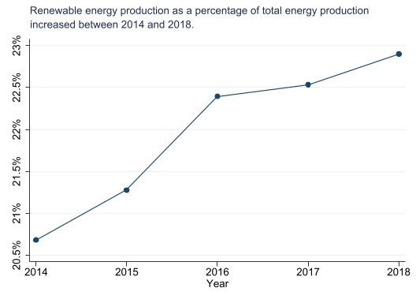 While total energy production increased between 2014 and 2018, average renewable energy production also increased within the same period. Not only did renewable energy production increase, but the rate at which it increased was greater than the rate at which production from other energy sources increased. This is shown by the fact that renewable energy production as a percentage of total energy production increased between 2014 and 2018 in the Middle East.

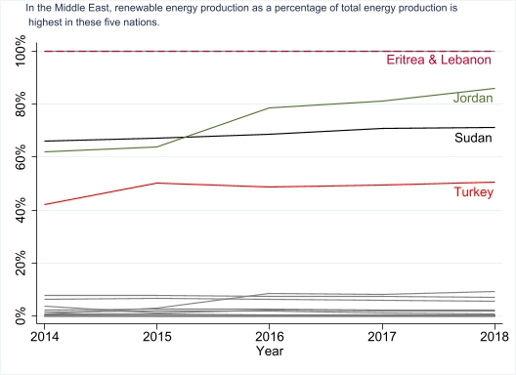 Within the Middle East, five countries produce 20% or more of their energy with renewable sources: Eritrea, Lebanon, Jordan, Sudan, and Turkey. For a region known for its oil production, these high levels of renewable energy production are surprising.

**IV. Empirical Design**

Due to the structure of the data, I used an event study to measure the differences in renewable energy production levels between the control group - the countries that have not yet ratified the agreement – and my treatment group - the countries that have ratified the agreement. I utilized an event study to measure the differences between these two groups because the countries that did ratify the agreement before 2019 did so in either 2016, 2017, or 2018.

By using the event study method, I can control for time-invariant differences between countries and trends in renewable energy production common to all countries. On the other hand, I will not be able to account for differences between countries that change over time, which includes variables like the political environment, war, GDP, and the population demographics of a certain nation.

For my model to deliver a causal estimate of the research question (i.e., changes in renewable energy production rates are caused by Paris Climate Accord ratification), I will need to test the assumption of common trends between the control group and the treatment group. This means that if none of the nations had ratified the Paris Accord, the control group and the treatment group would show similar trends of renewable energy production over time. With the event study format, I will need the variables for event time less than -1 to be equal to or close to zero. If this holds true, I can reasonably assume that parallel trends are satisfied and will be able to derive a causal estimate.

 My estimating equation is as follows:

|  |
| --- |
| **Yct = Στβτ1(t − Es = τ) + γc + θt +β2GDP + ϵct** |

where:

**Yct** = renewable energy as a percentage of total energy production in the country

**t − Es = τ** = event time

**Στβτ1** = the difference in expected Y between the **τ**th event time and event time -1

**θt** = country fixed effects

**γc** = year fixed effects

**β2** = the effect of country GDP on renewable energy production

**ϵct** = error term

**V. Results**

The table below shows the main impacts of ratification on renewable energy production as a percentage of total energy production in Middle Eastern countries. In the simple regression, ratification of the Paris Climate Accord is associated with a 12.9% decrease in renewable energy production as a percentage of total energy production. However, this regression does not take advantage of the panel nature of the data, which is why I have included the two fixed effects regressions that will better deliver the causal effect of ratification on renewable energy production.

|  |  |  |  |
| --- | --- | --- | --- |
| **VARIABLES** | **Simple Regression** | **Fixed Effects - Event Study** | **Fixed Effects - Event Study w/ GDP** |
|  |  |  |  |
| 4 Years Before Ratification |  | 0.00405 | 0.0143 |
|  |  | (0.0318) | (0.0417) |
| 3 Years Before Ratification |  | 0.00444 | 0.00405 |
|  |  | (0.0157) | (0.0212) |
| 2 Years Before Ratification |  | -0.00406 | -0.00194 |
|  |  | (0.0123) | (0.0143) |
| Year of Ratification |  | 0.0159 | 0.0184 |
|  |  | (0.0123) | (0.0141) |
| 1 Year After Ratification |  | 0.0199 | 0.0239 |
|  |  | (0.0127) | (0.0148) |
| 2 Years After Ratification |  | 0.0359** | 0.0393** |
|  |  | (0.0157) | (0.0178) |
| Ratified | -0.129* |  |  |
|  | (0.0734) |  |  |
| GDP per capita ($USD) |  |  | -6.59e-07 |
|  |  |  | (1.43e-06) |
| Constant | 0.287*** | 0.214*** | 0.196*** |
|  | (0.0614) | (0.00497) | (0.0240) |
|  |  |  |  |
| Observations | 95 | 95 | 82 |
| R-squared | 0.033 | 0.118 | 0.132 |
| Number of Country Code |  | 19 | 17 |
| **Robust standard errors in parentheses** |  |  |  |
| **\*\*\* p<0.01, ** p<0.05, *p<0.1** |  |  |  |

In the first fixed effects event study regression, the only statistically significant variable at any level is the *2 Years After Ratification* variable with a p-value of 2.5%. This shows that the average renewable energy production as a percentage of total energy production two years after ratification is 3.59% greater relative to the year before treatment. I can also check the common trends assumption from this regression by looking at the variables *4 Years Before Ratification*, *3 Years Before Ratification*, and *2 Years Before Ratification*. These estimates are 0.41%, 0.44%, and -0.41%, respectively. Ideally, these estimates should be 0 to verify the common trends assumption, but they are all incredibly close to 0, meaning the common trends assumption is still satisfied.

The second fixed effects event study regression includes GDP per capita (in USD) to control for a potential source of omitted variable bias. Again, the only statistically significant variable at any level is the *2 Years After Ratification* variable with a p-value of 3.1%, but the effect increased in this regression. Specifically, average renewable energy production as a percentage of total energy production two years after ratification is 3.93% greater relative to the year before treatment. As for checking the common trends assumption, the values of *4 Years Before Ratification*, *3 Years Before Ratification*, and *2 Years Before Ratification* are all similar to the previous regression (1.43%, 0.41%, and -0.19%, respectively). These should ideally be closer to 0, but they are small enough that the common trends assumption is still satisfied.

The below graph shows the results of my second event study with GDP, effectively visualizing the effects of ratification. Specifically, the graph proves the common trends assumption captured by the regression, as the estimates less than event time -1 are close to or equal to zero. The graph also visualizes the effects of ratification at the time of ratification, 1 year after ratification, and 2 years after ratification, with an increasing trend after ratification.

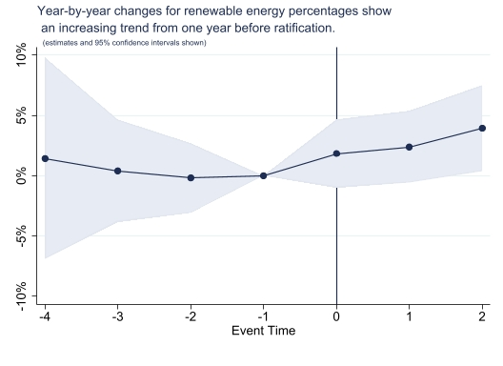

The average renewable energy production as a percentage of total energy production in the entire data set is 21.96%. Considering this, 3.59% and 3.93% are very economically significant percentages, as they represent large increases in energy production. This shows that ratification of the Paris Climate Accord has had a significant impact on renewable energy production levels, which demonstrates why ratifying and implementing the agreement is so crucial for preserving the global climate going forward.

One possible confounding factor with the regression is that most of the countries in the dataset signed and ratified the climate agreement in the same year, mostly in 2016. This means that the true effect on renewable energy production could be from signing and not ratifying the agreement. Since data is limited to before 2018, I was unable to accurately distinguish between the two factors. As more recent data becomes publicly available, this distinction should be made to ensure the accuracy of these estimates.

**VI. Conclusion**

This paper seeks to answer the question of how ratification of the Paris Climate Agreement affects renewable energy production as a percentage of total energy production. By using a sample of Middle Eastern countries and exploiting the panel nature of the data, I was able to determine how ratification directly affects renewable energy production in a country. With 95% confidence, the regression estimates show that ratification increases renewable energy production as a percentage of total energy production by 3.93% two years after the event compared to one year before the event, controlling for GDP per capita of a country.

As more energy production data is released to the public, more research will be needed to accurately define the impact of ratification versus simply signing the agreement. Despite this, these estimates will be crucial for convincing the remaining countries that have not yet ratified the Paris Climate Accord that ratification makes a difference, while also aiding the global community’s push to reverse harmful climate change trends.

REFERENCES

1. International Energy Agency. 2021. “Data Balances.” *Data and Statistics.*